An Example of Abstract for the Supersolid Workshop

Keiichi Yamamoto,¹ Y. Shibayama,¹ C. Superduper,^{1,2} and K. Shirahama¹

¹Department of Physics, Keio University, Yokohama 223-8522, Japan
²Institute for Solid State Physics, University of Tokyo, Kashiwanoha 5-1-5, Kashiwa 277-8581, Japan

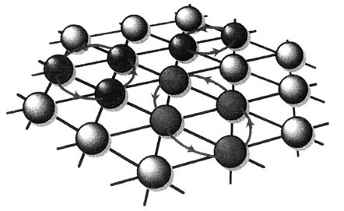
This is an abstract template for the PSM Workshop on Physics of Supersolid and Related Topics. Please send the Word file with your registration e-mail to Keiya Shirahama,
FIG.1: Schematic drawing of two-, three-, and four-particle exchanges in a triangular lattice.

keiya@rk.phys.keio.ac.jp
as an attachment. The deadline for the abstract submission is 28th February 2007. The abstract should be within one age of A4 size, but may be extended to two pages if needed.
The margins of each page are 25 mm for four sides. The recommended font is Times New Roman, Helvetica, Arial, or a similar font. The font size is 14 pt. for the title. Author names are written with the font of Times New Roman or a similar font, and their size is 12 pt. The affiliations of the authors are written with Times New Roman or a similar font. They are of 11 pt in size and are slanted. The authors and the affiliations are related with serial numbers. The font is Times New Roman or a similar font and the size is 11 pt.
The references are cited with a number between parentheses, like [1]. Figures are inserted at suitable positions (Fig.1).
[1] G. Goofy et al., Phys. Rev. Lett. 99, 123456 1-4 (2006).

